Lab Manual

# *ARTIFICIAL INTELLIGENCE*

##### **Lab task 1 (libraries):**

**1. NumPy**

* **Purpose:** A fundamental library for numerical computing in Python.
* **Key Features:**
  + Supports multi-dimensional arrays and matrices.
  + Provides mathematical functions for operations on arrays.
  + Often used as the base for other libraries like TensorFlow and Pandas.
* **Example Use Case:**

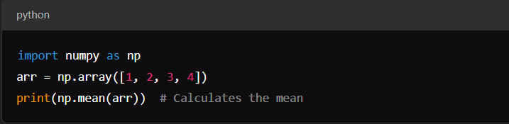

**2. TensorFlow**

* **Purpose:** A powerful library for building and training machine learning and deep learning models.
* **Key Features:**
  + Supports computational graphs and automatic differentiation.
  + Used for large-scale neural networks, including Convolutional Neural Networks (CNNs) and Recurrent Neural Networks (RNNs).
  + Compatible with both CPU and GPU for optimized performance.
* **Example Use Case:**

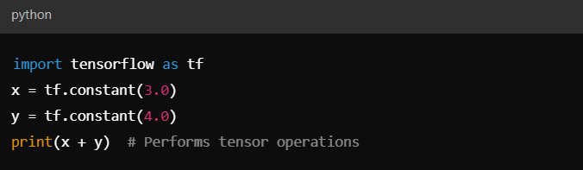

**3. Keras**

* **Purpose:** A high-level neural networks API, built on top of TensorFlow.
* **Key Features:**
  + Simplifies building and training deep learning models.
  + Supports both sequential and functional model building.
  + Provides pre-trained models for common architectures.
* **Example Use Case:**

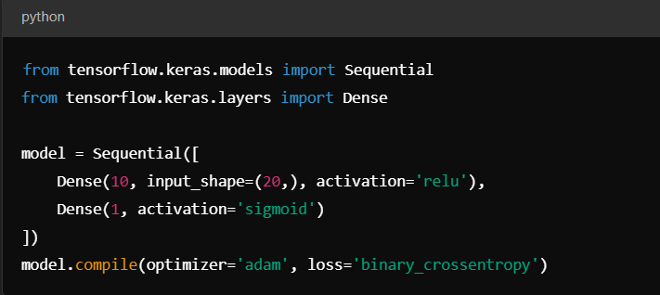

**4. Pandas**

* **Purpose:** A data manipulation and analysis library.
* **Key Features:**
  + Provides data structures like DataFrames and Series for handling tabular data.
  + Supports data cleaning, transformation, and aggregation.
* **Example Use Case:**

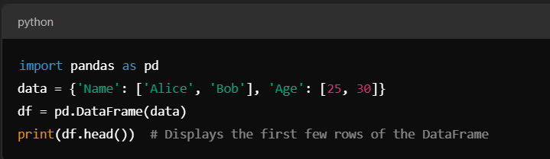

**5. Matplotlib**

* **Purpose:** A plotting library for creating static, interactive, and animated visualizations.
* **Key Features:**
  + Enables line plots, bar charts, scatter plots, and more.
  + Highly customizable for creating publication-quality visuals.
* **Example Use Case:**

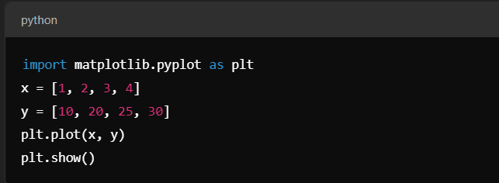

##### **Lab Task (TABLE):**

# **Table of 5:**

* Input table:

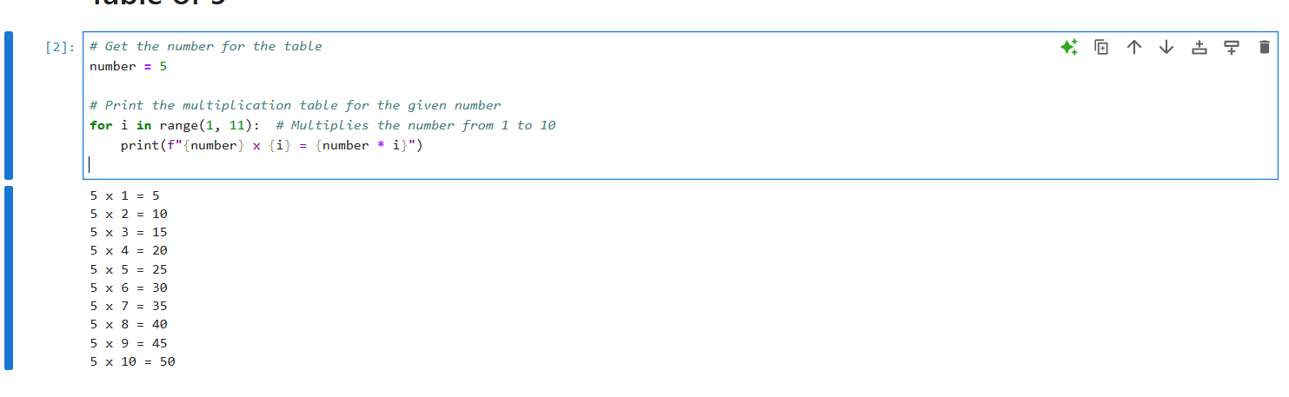

Output:

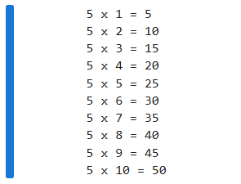

* Swapping:

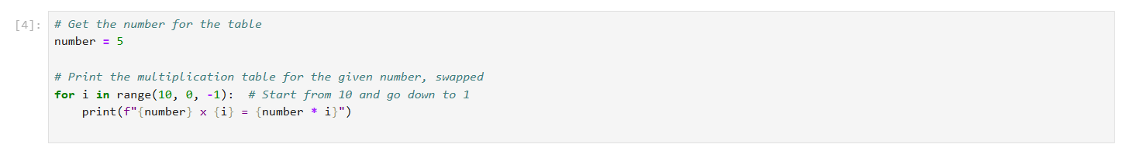

Output:

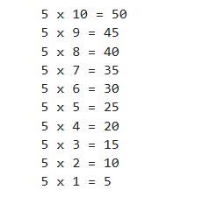

##### **LAB TASK 3 (upper and lower CASES)**

# **Swap Cases:**

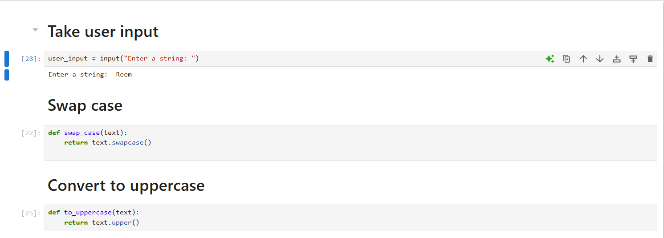

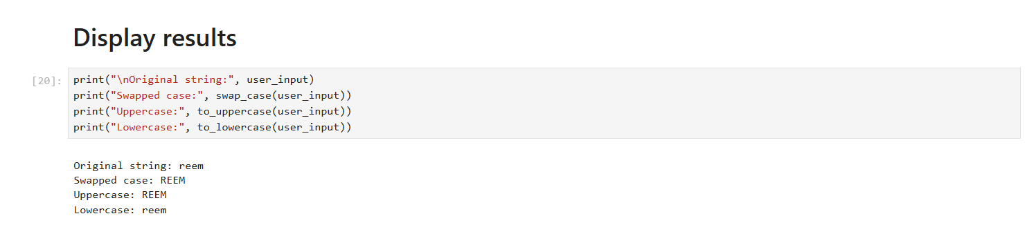

Output:



##### **LAB TASK 4 (MODEL TRAINING)**

# **TRAINING model:**

* Read CSV file:

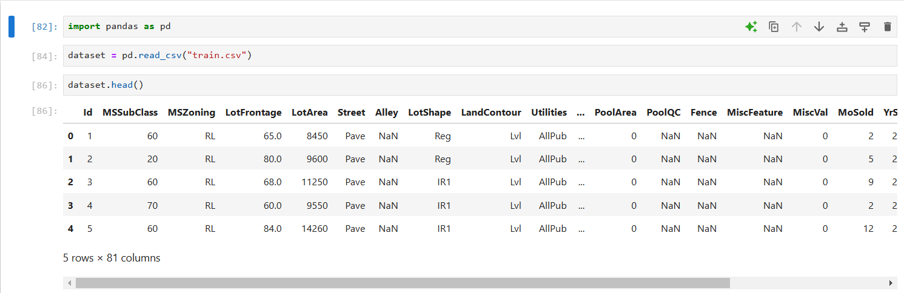

* Import libraries:

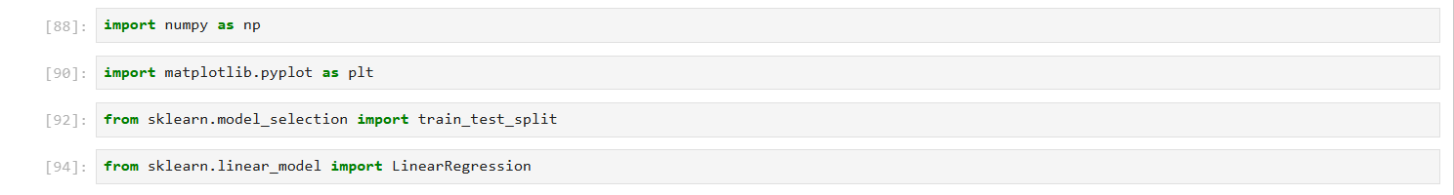

* Generate & load dataset:

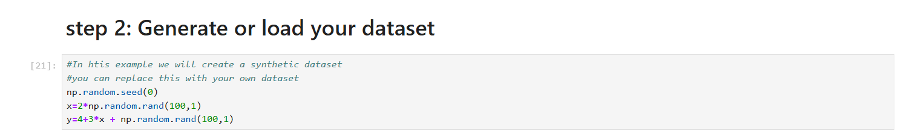

* Split dataset:

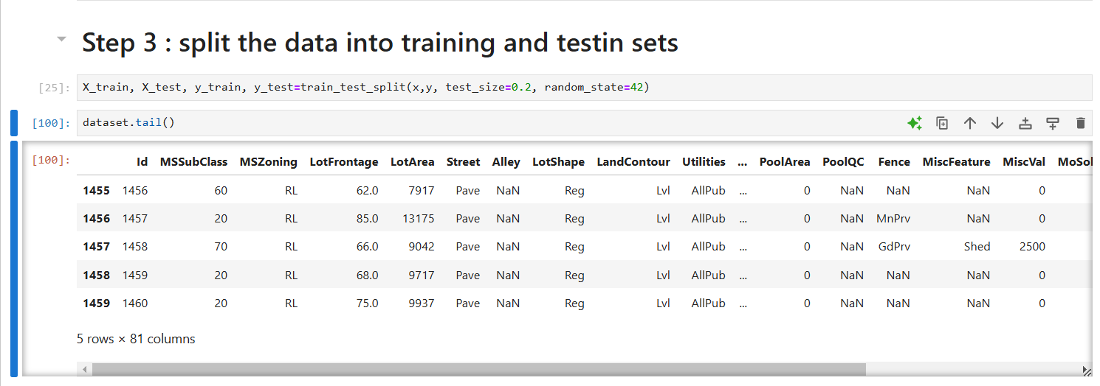

* Linear regression:



* Train model:

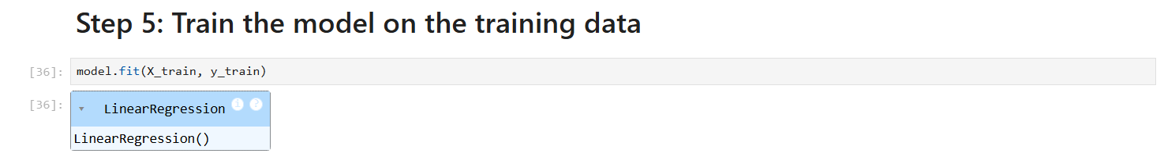

* Train model:

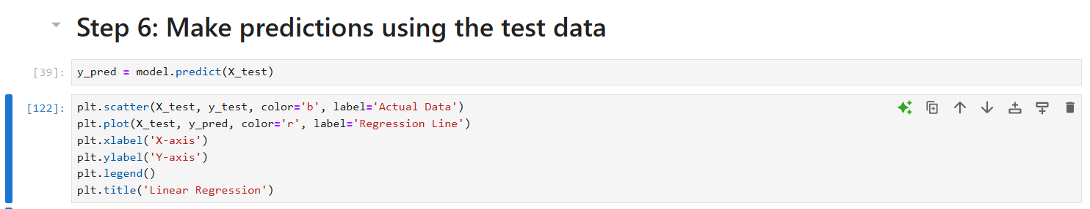

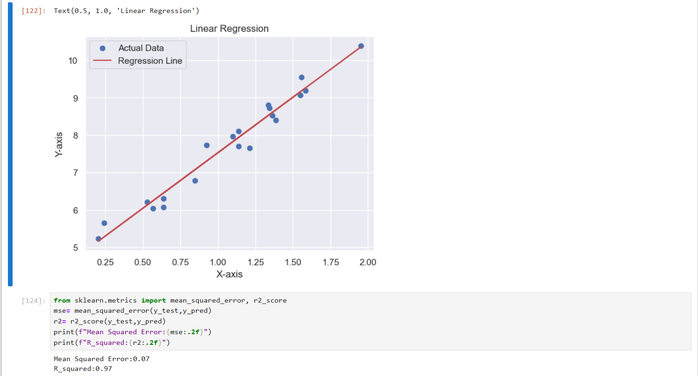

##### **LAB TASK 5 (IMG processing)**

# **ERosion/dilation:**

* Import libraries:

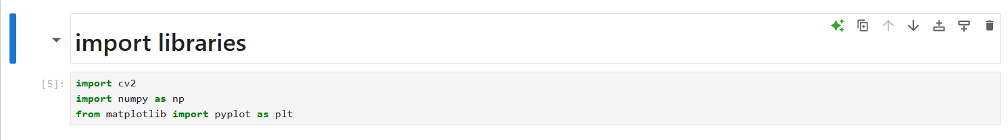

* Load /Crop:

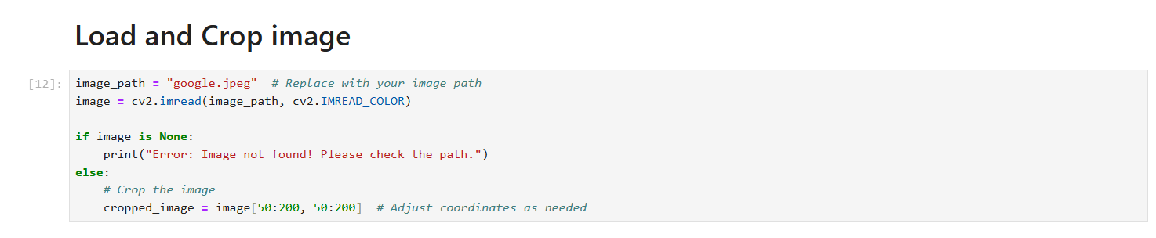

* Erosion/Dilation:

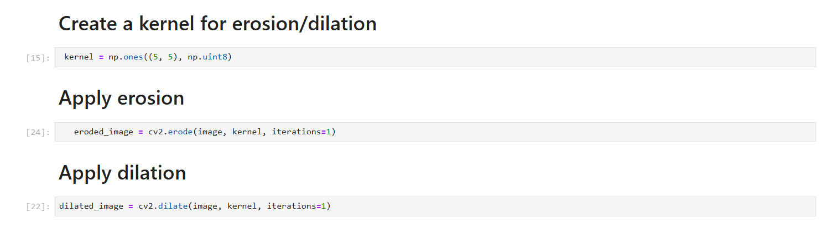

* Results:

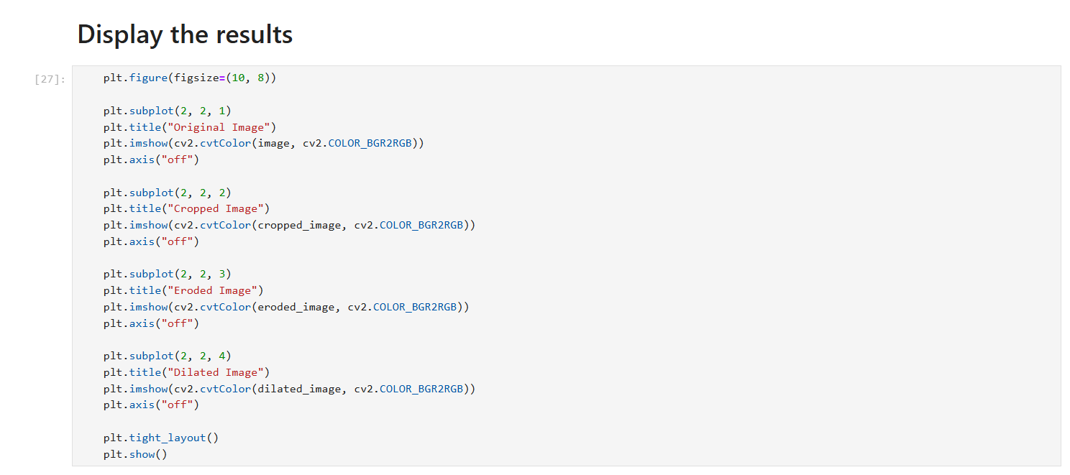

Output:

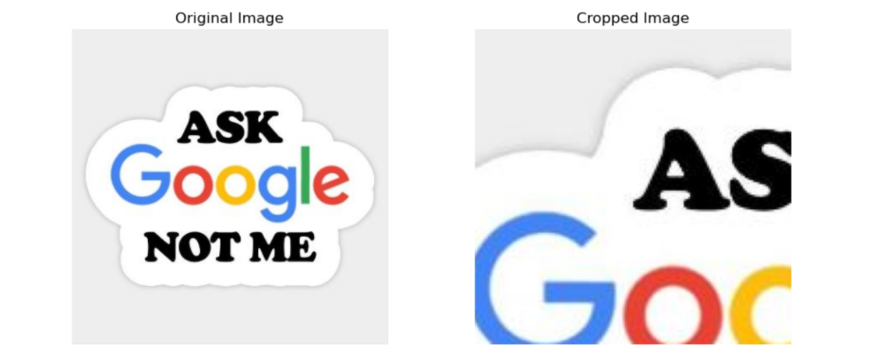

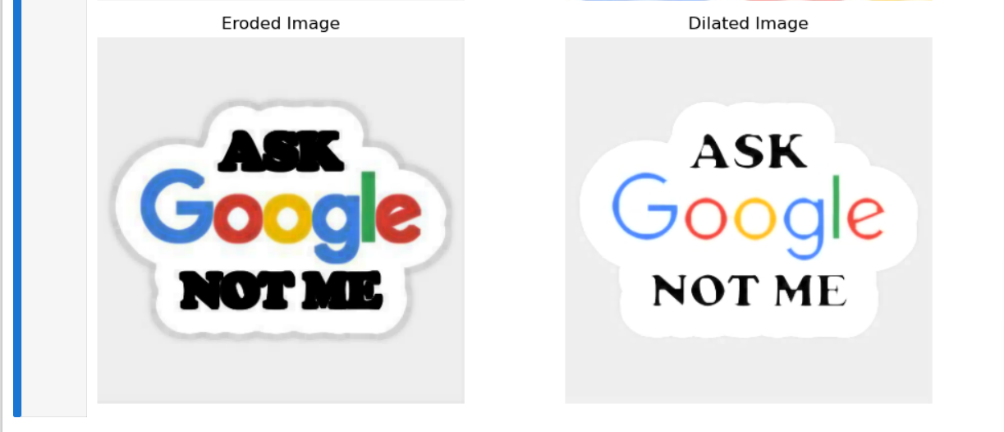

##### **LAB TASK 6 (layers/sigmoid)**

# **ANN:**

* Install tensorflow:

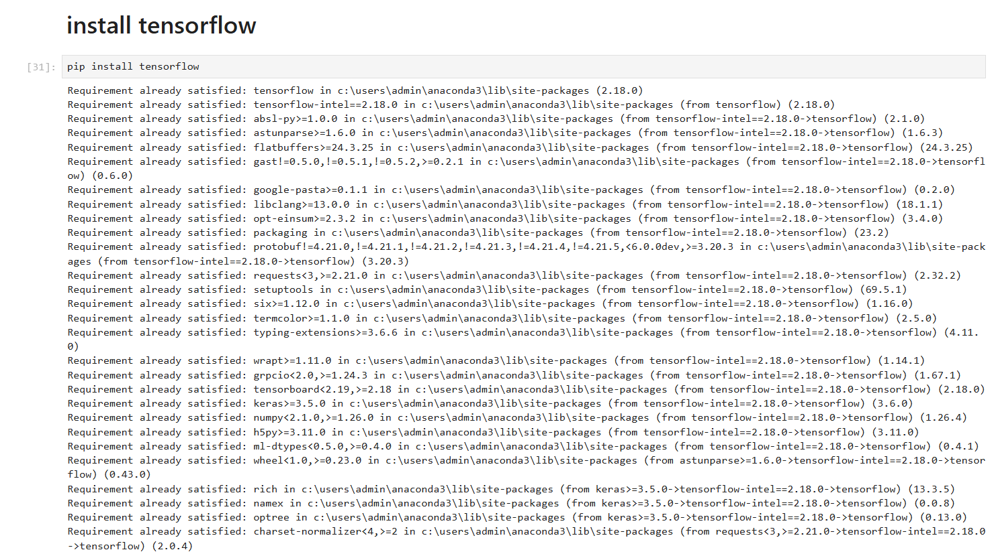

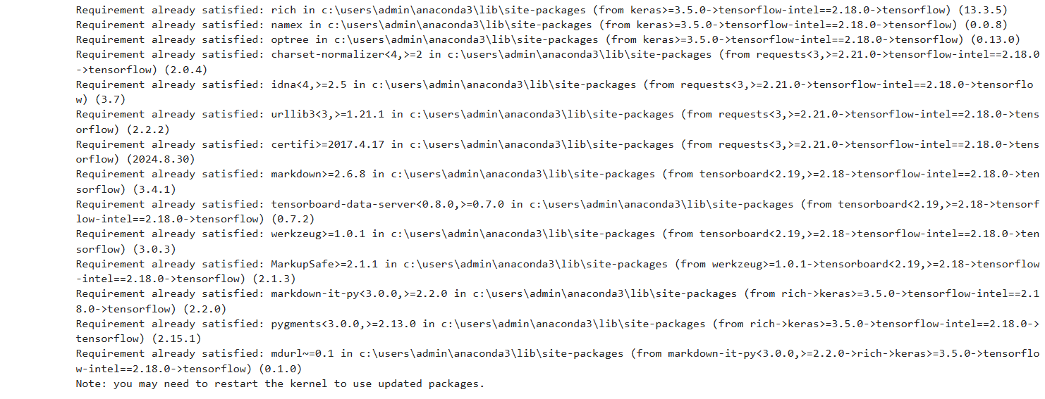

* Import libraries:

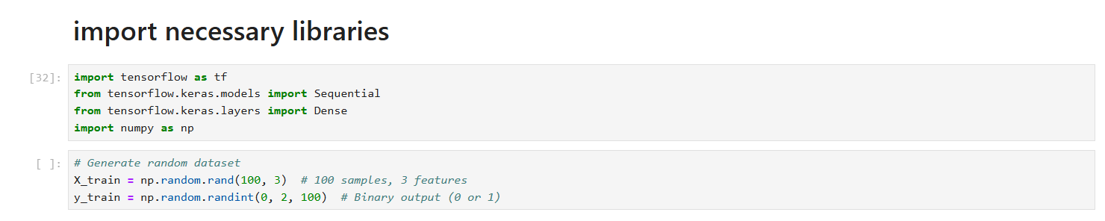

* Building model:

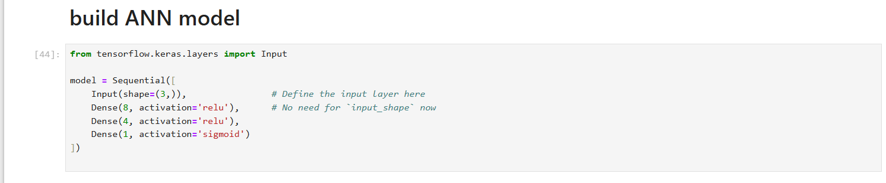

* Model compilation:

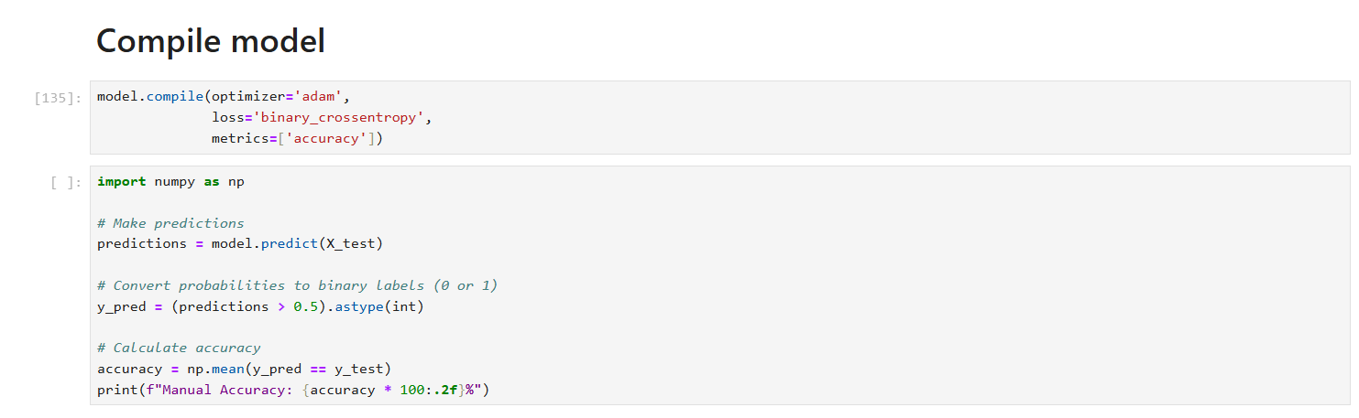

* Training model:

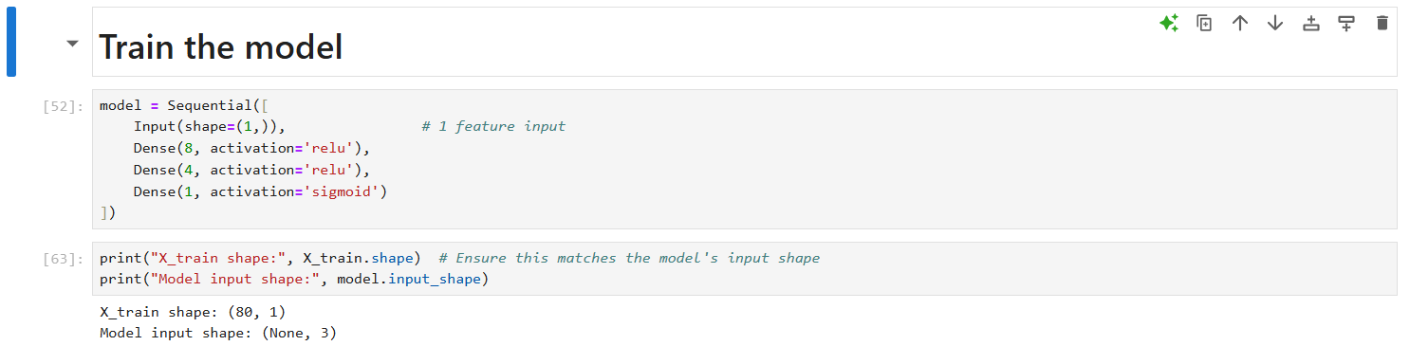

* Evaluation:

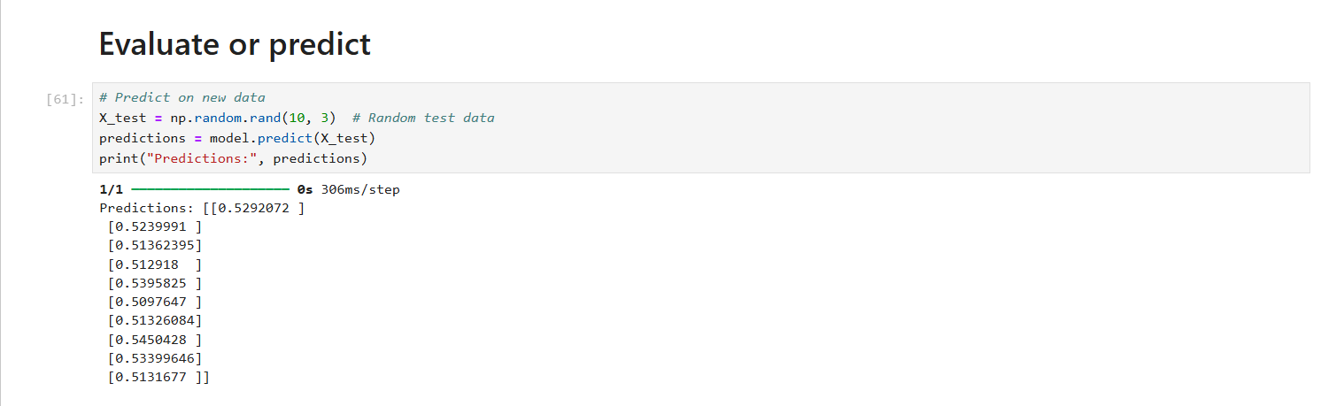

* Full code:

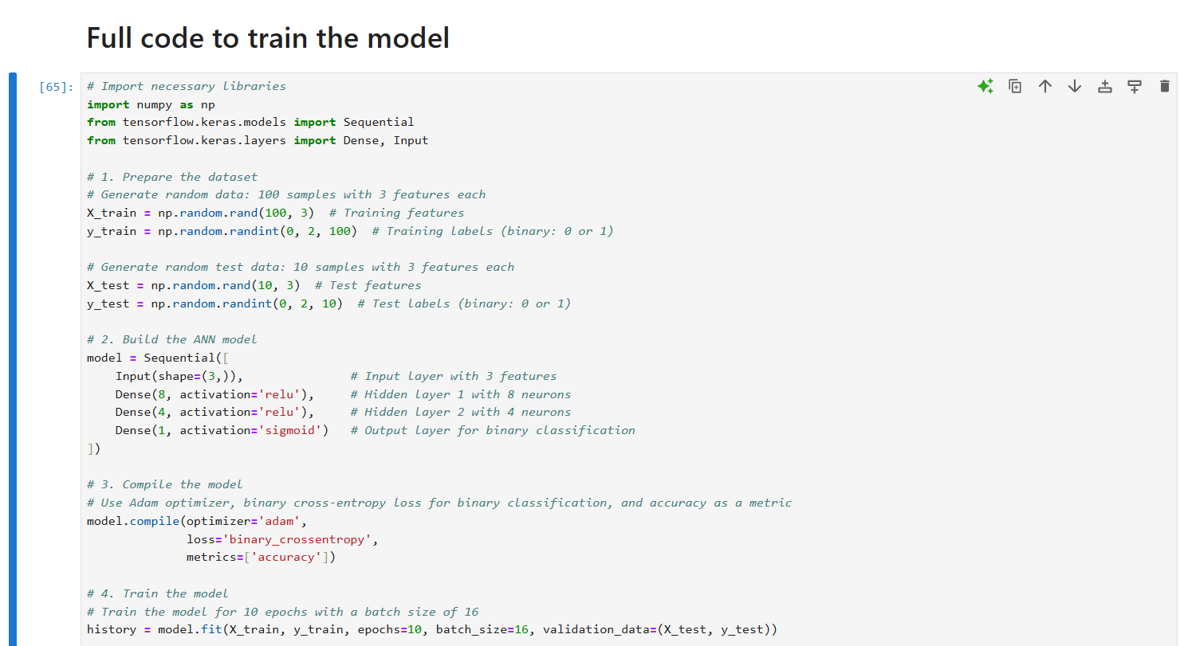 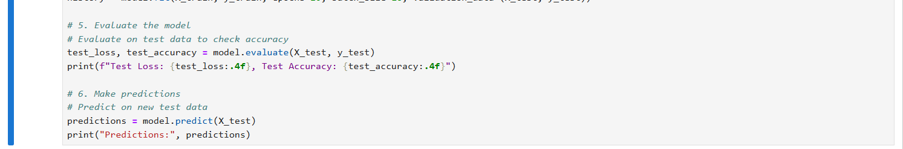

Output:

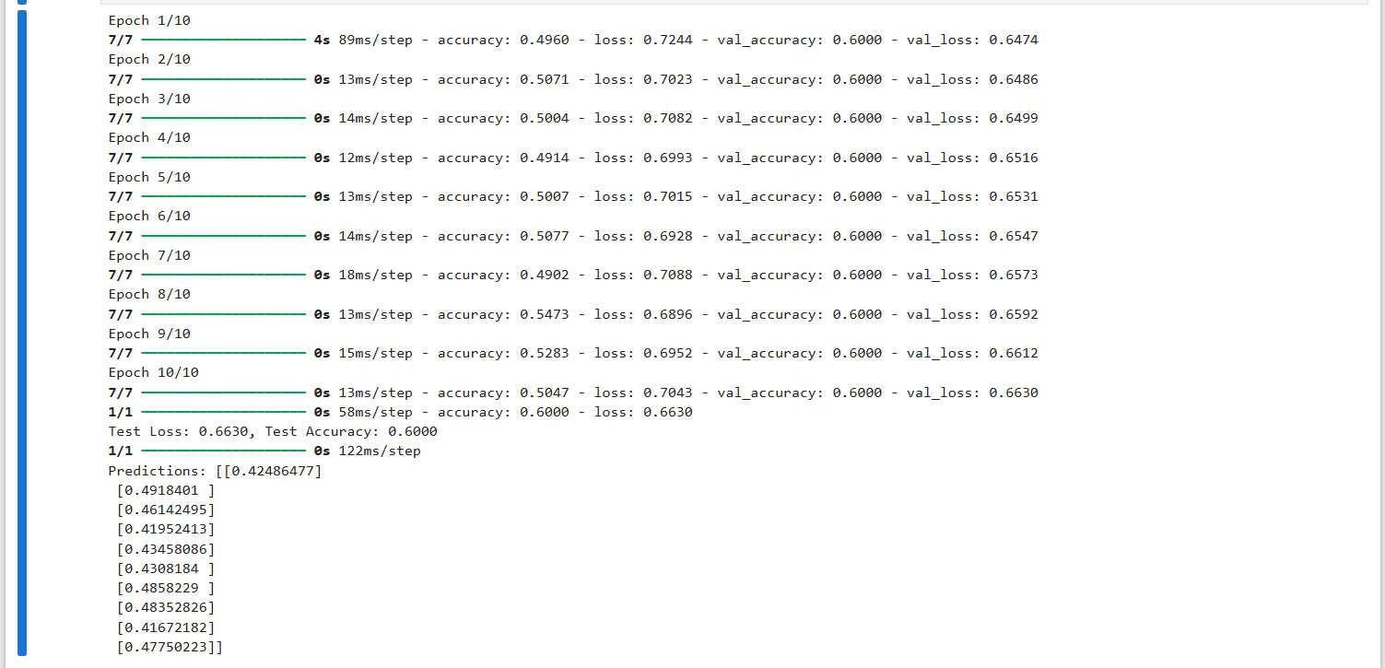

##### **LAB TASK 7 (grayscale)**

# **zip file images:**

* Import libraries:

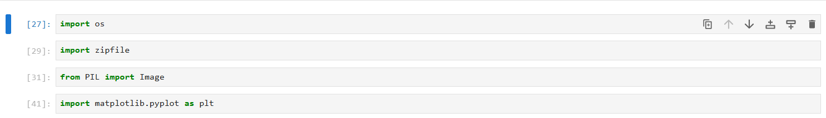

* Specifying extraction:

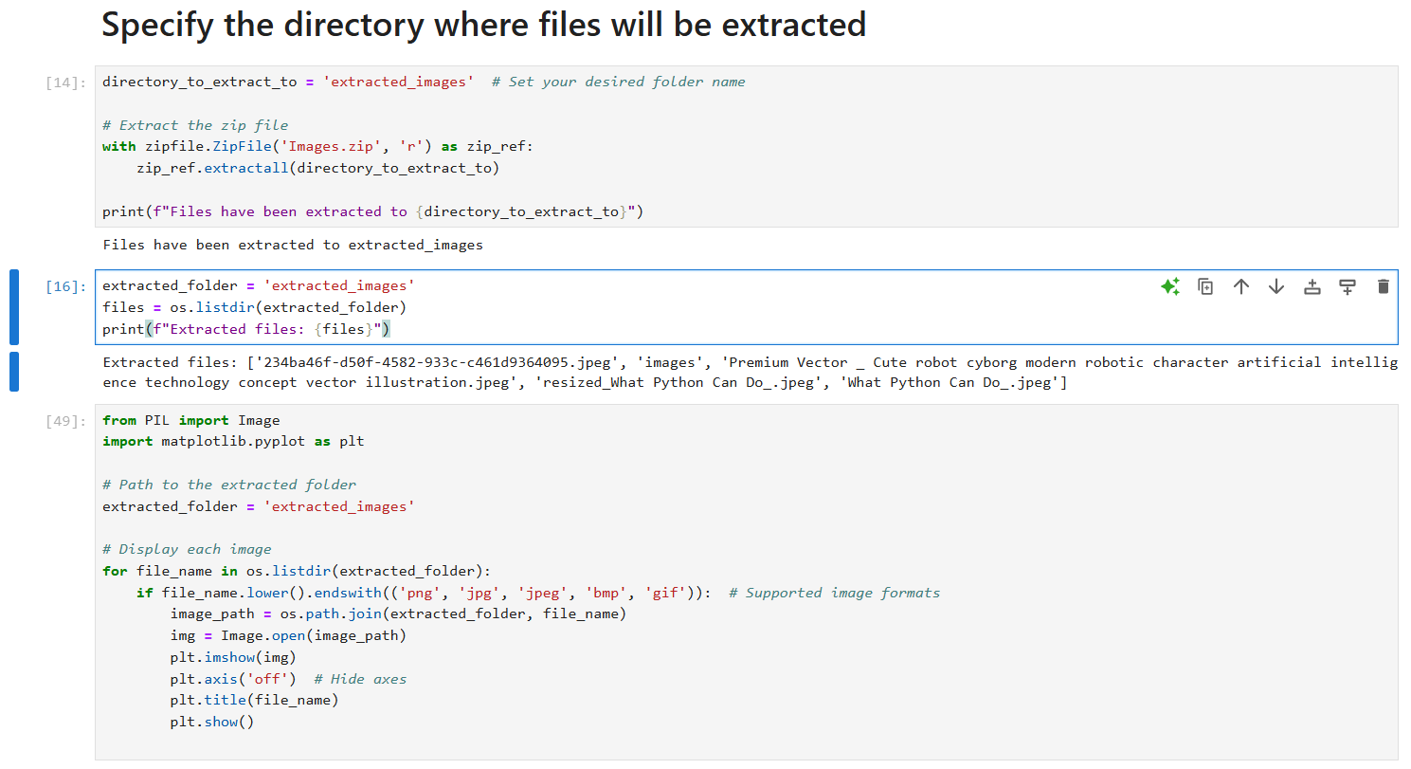

Result:

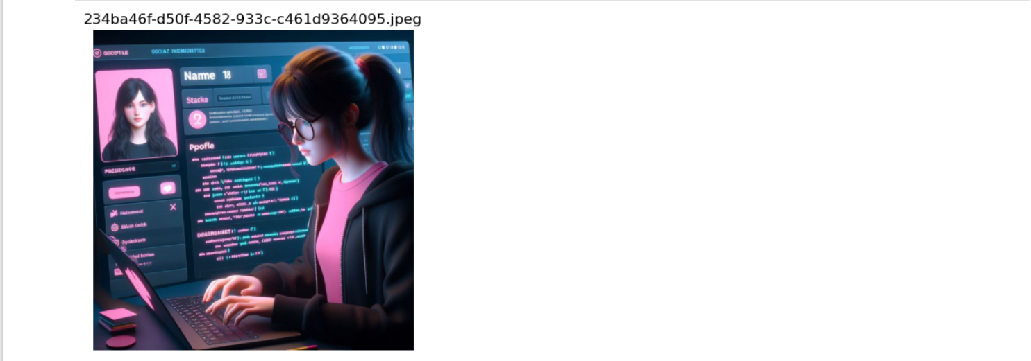 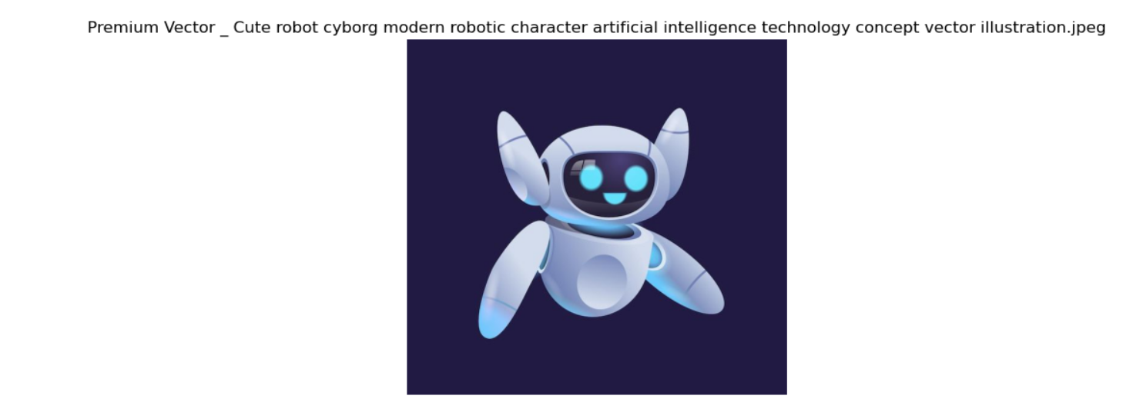 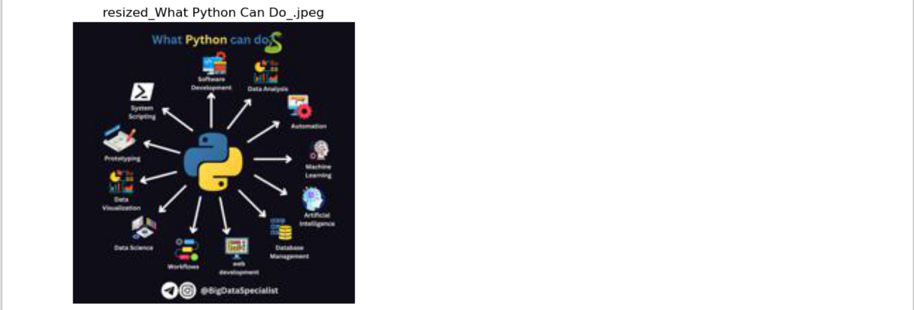 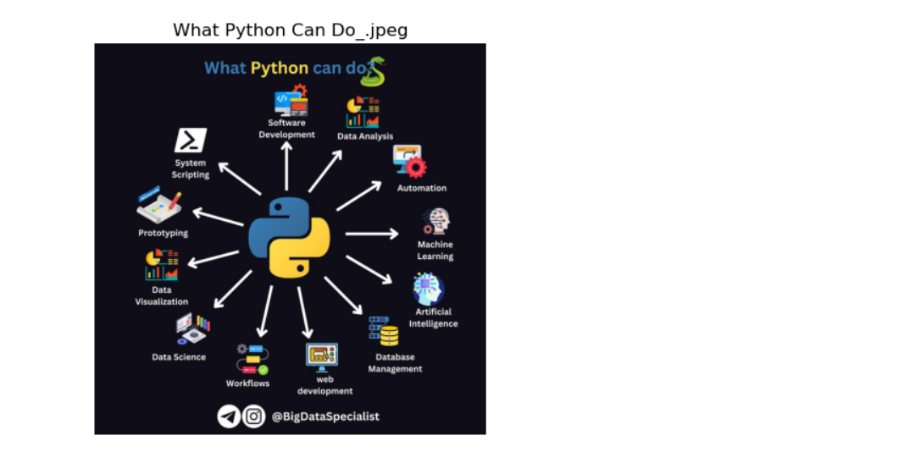

* Gray-scale:

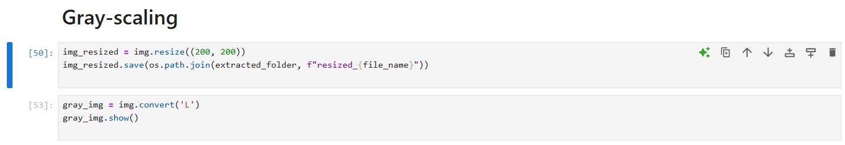 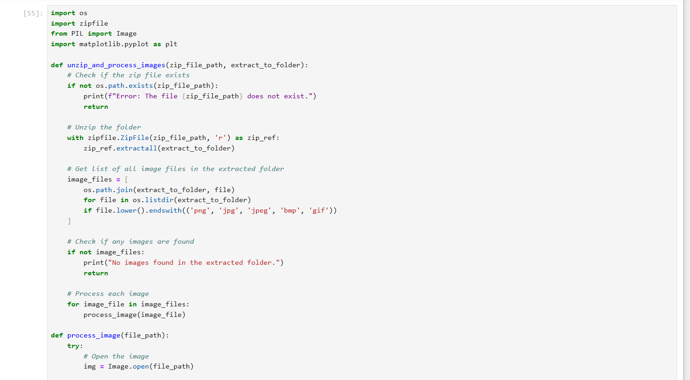 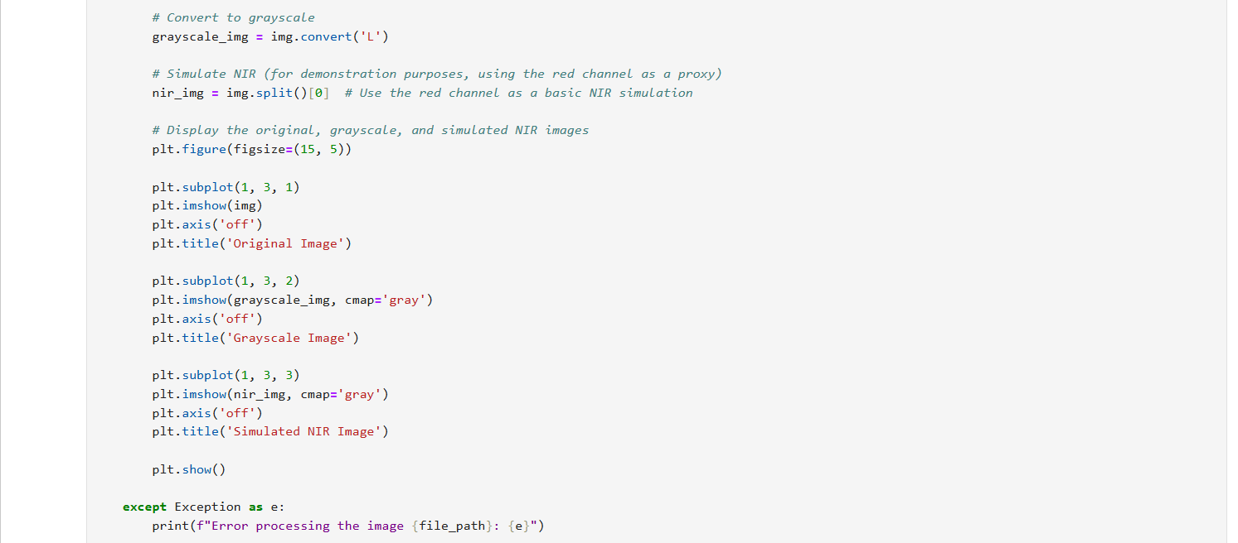 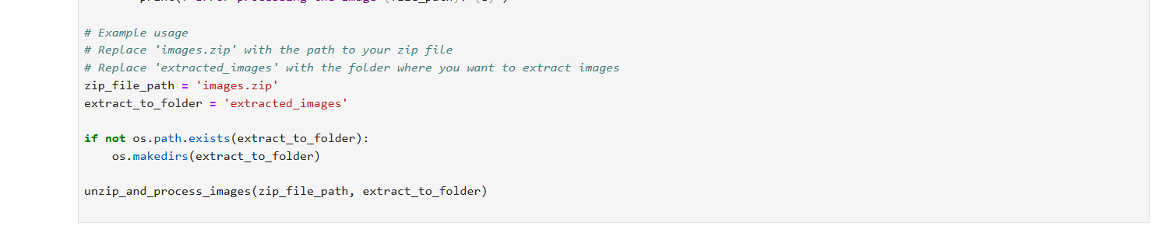

Result:

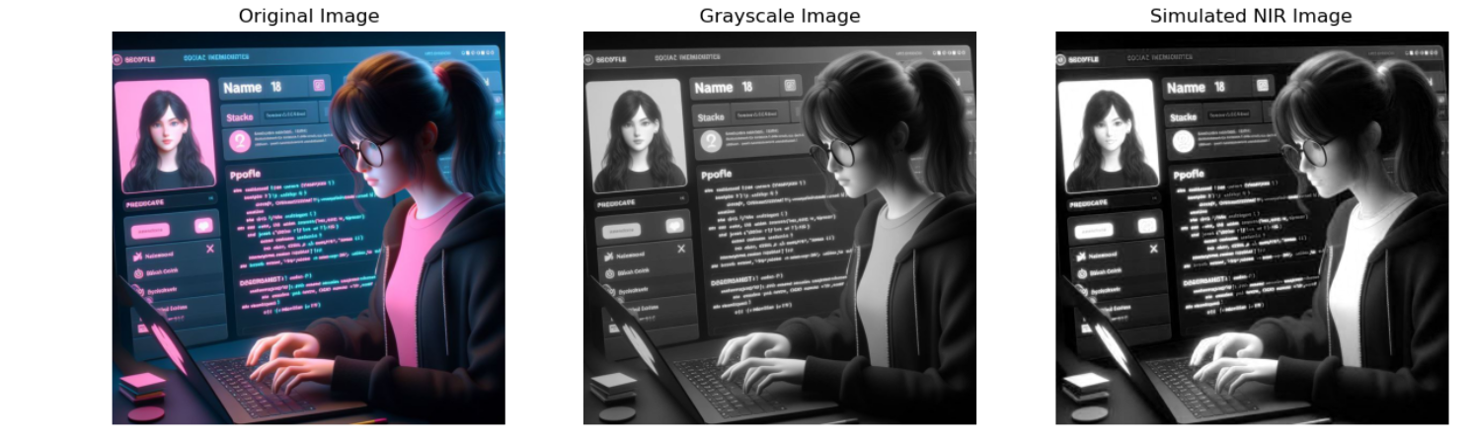 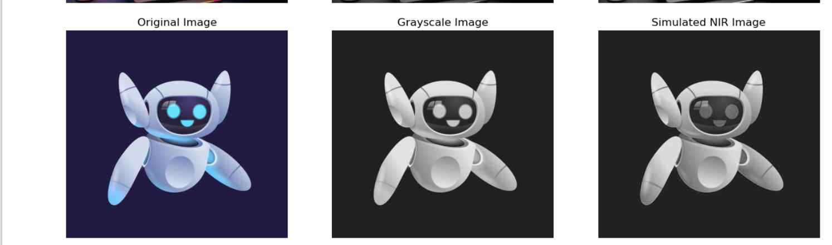 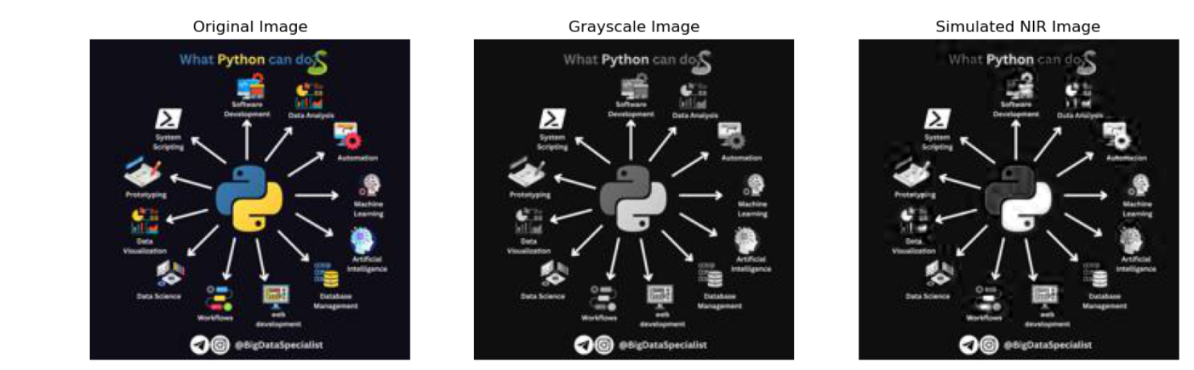 

##### **LAB TASK 8 (background remove)**

# **Remove BG:**

* Find path:

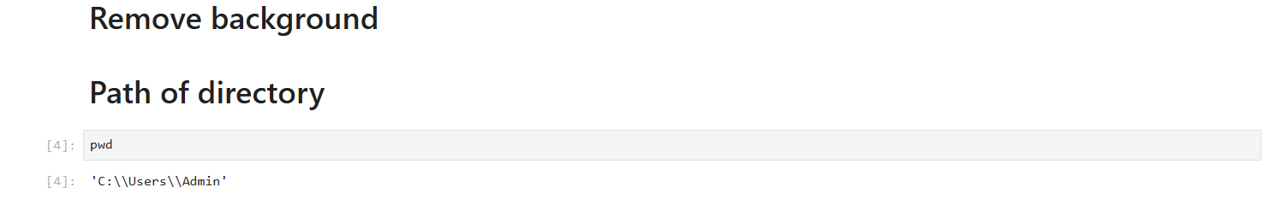

* Select img path:

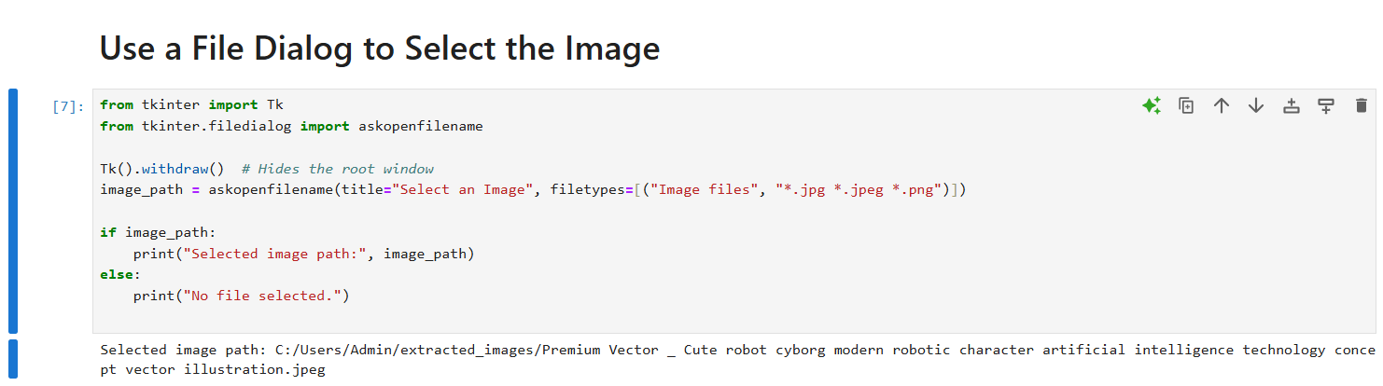

* Remove background:

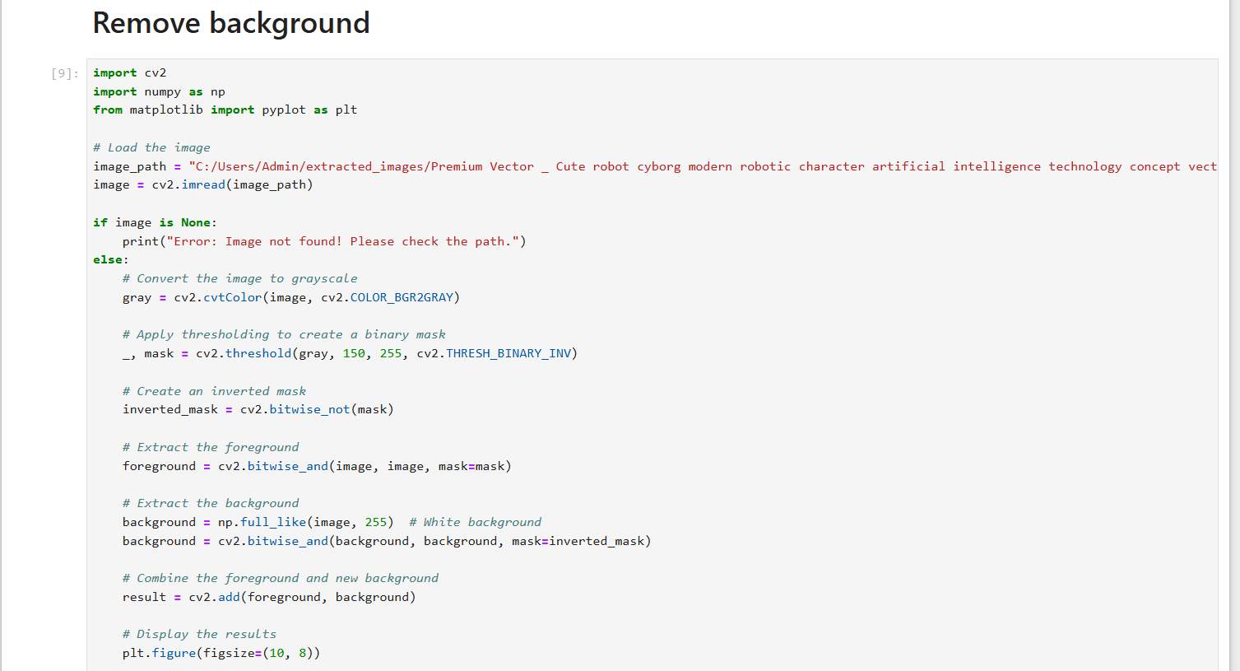

* Display results:

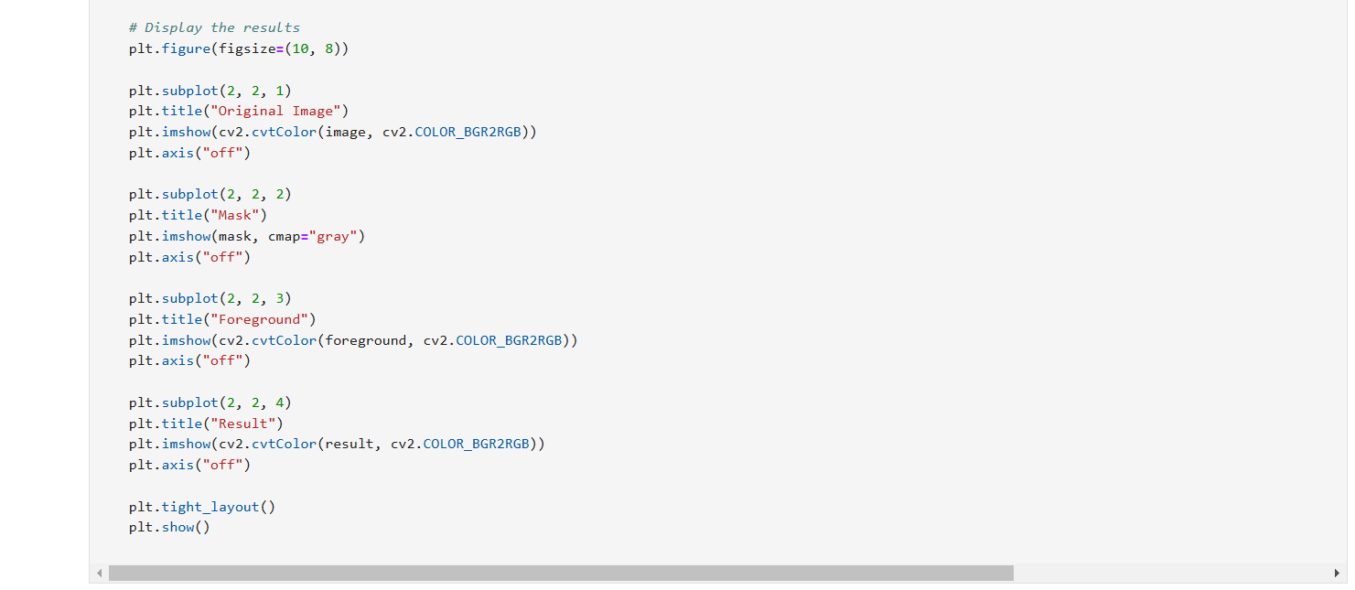

Output:

